B302061510 (left- original/ right- with dhw tank)

Q_losses = Q_distribution_loss + Q_tank_loss

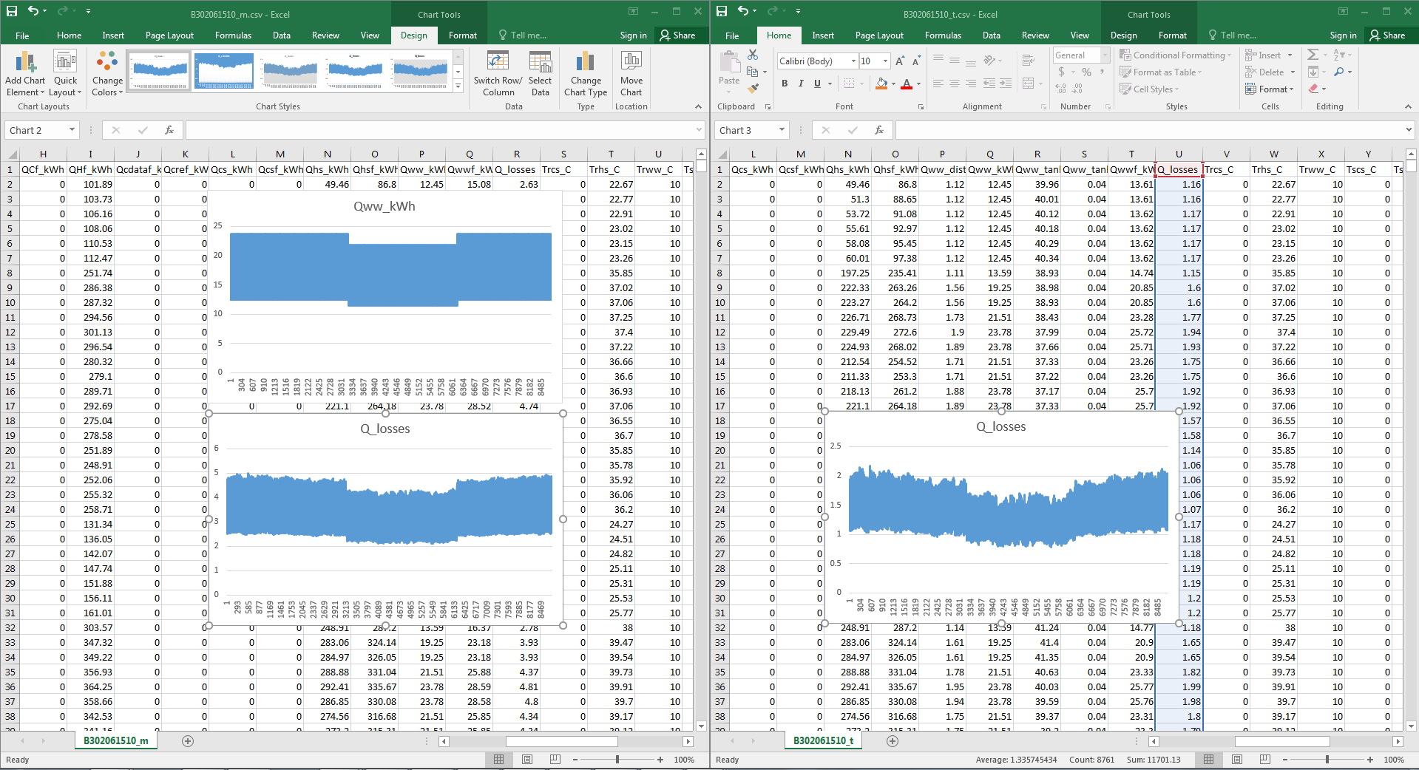

B302049837

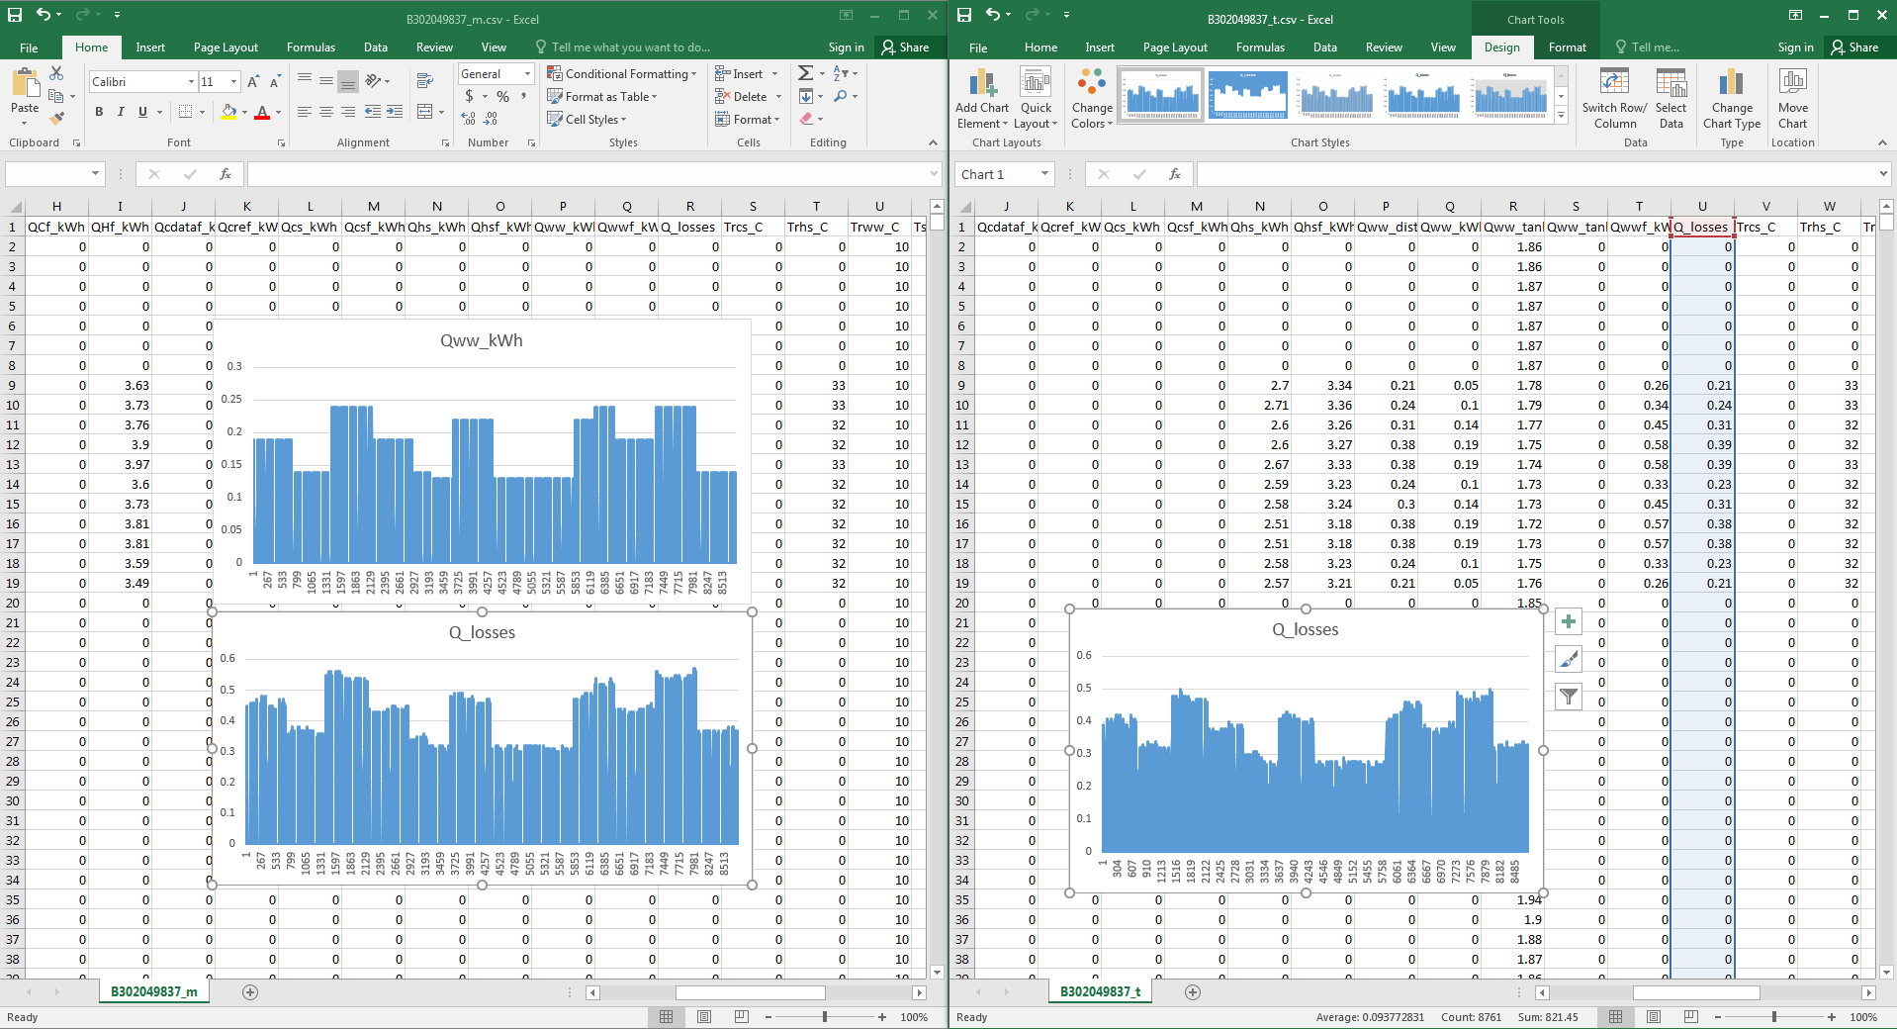

B302049821

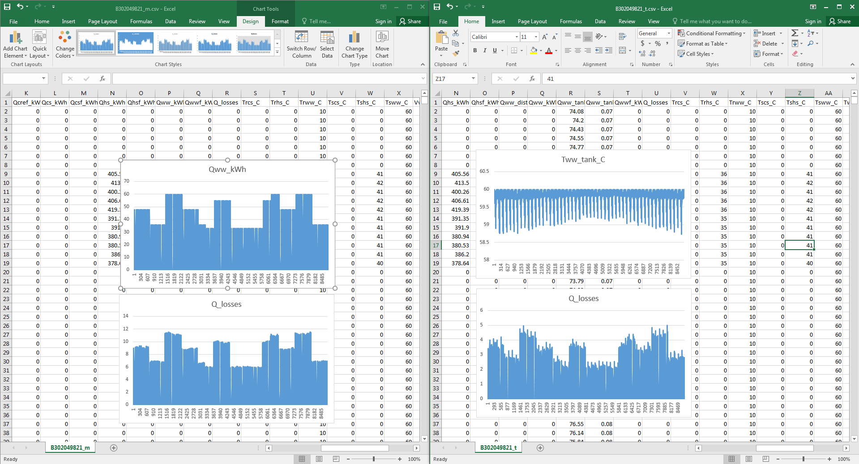

Spiking Q_losses at the beginning of each demand period to bring tank temperature to set point.